Setting up LAPS on Intune

Step 1:
Go into the Entra admin console and enable LAPS for the whole tenant
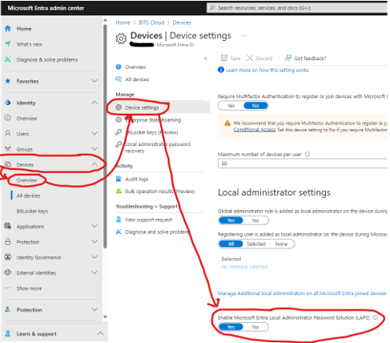
Step 2:
Create a new script that creates a local admin called ‘Boundary’ to manage with LAPS
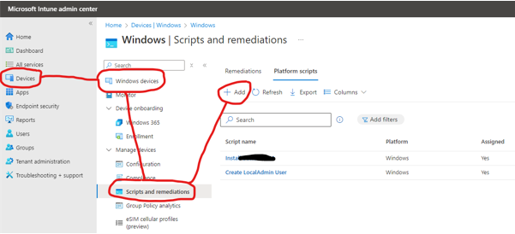
Name it ‘Create Local Admin’ and click Next
Setup the script as below:
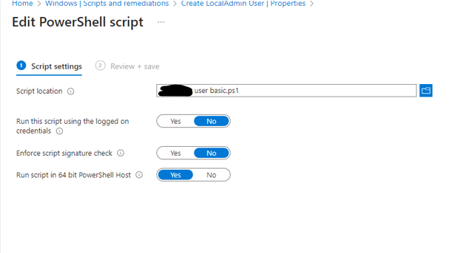
Save that and move onto the assignment step
Assign to a group if doing it for certain computers or to all computers if doing it for whole tenant.

Step 3:
Click Enpoint security, account protection and create policy. Select platform windows and profile ‘Local Admin Password Solution’
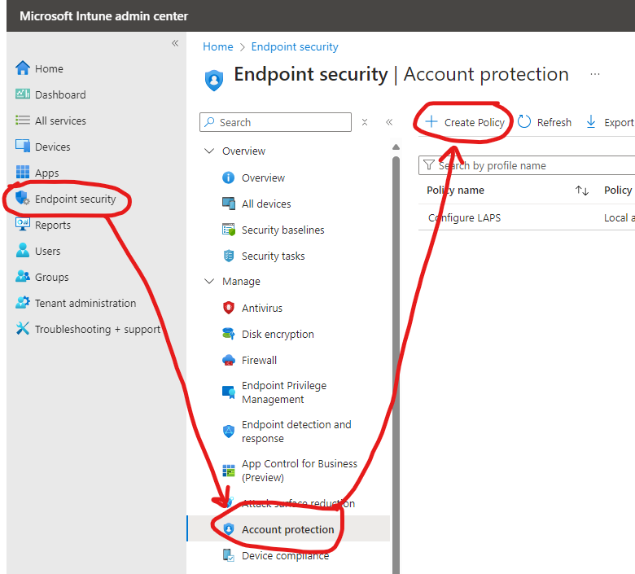
Call it ‘Configure LAPS’ and click next
Set the settings as below and click next
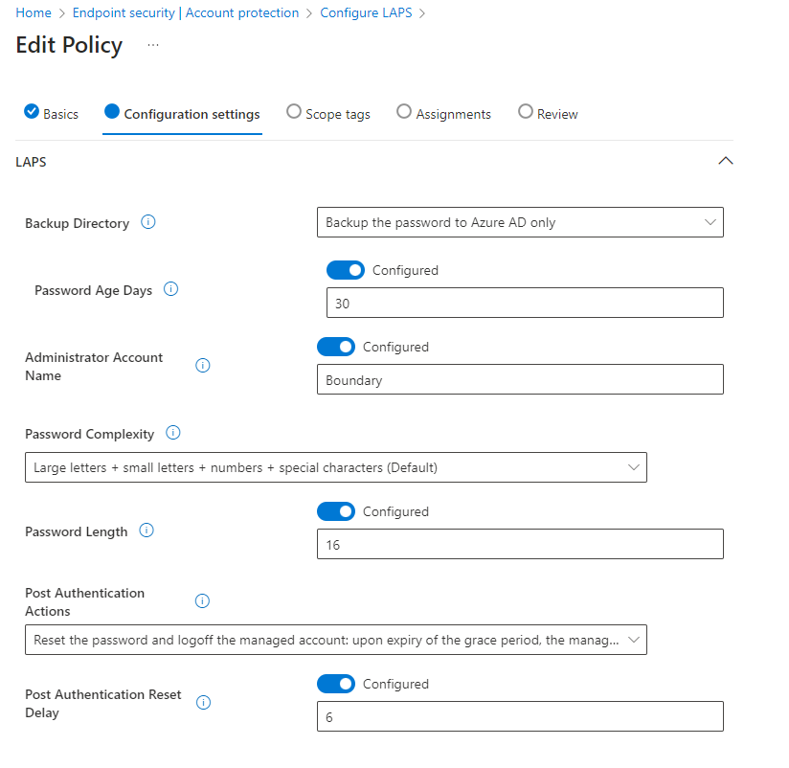
Leave scope alone and click next. Assign it to the LAPS Enable group or to all computers depending on what is required and save the policy
Step 4:
Still in the Account protection section of Intune create another policy. Select platform windows and profile ‘Local user group membership’
Call it ‘Remove Admin Users’
Add a group configuration make sure it is set to the administrators local group, set to add (replace) so it replaces all local admins, change the user selection to manual and click select users
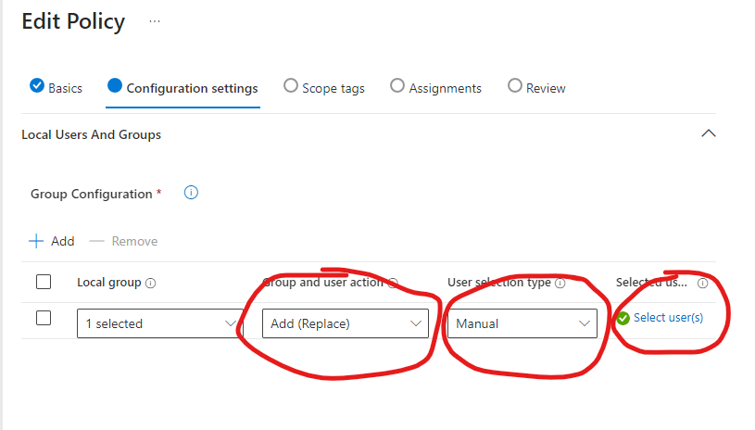
Make the user list look like this
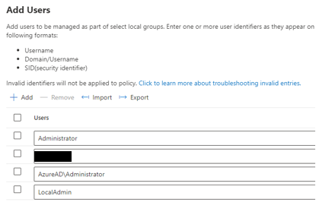
The in assignments either assign to a group or to the all computers and save the policy
All done now you can force sync on the client, reboot or leave it for an hour and you should be good to go

